7.2.1 Editors - 3D View - Header - Object menu
Detailed Table of content 2
Object Mode - Object menu 3
Convert to 3
Curve from Mesh/Text 3
Mesh from Curve/Meta/Surf/Text 3
Last Operator Convert to 3
Show/Hide 3
Game 4
Subdivide 4
Last Operator Subdivision Set 4
Level 4
Relative 4
Quick Effects 4
Quick Fur 4
Quick Explode 4
Quick Smoke 5
Quick Fluid 5
Constraints 5
Add Constraints ( With Targets) 5
Last Operator Add Constraints (with Target) 6
Type 6
Copy Constraints to Selected Objects 6
Clear Object Constraints 6
Clear Track 7
Last Operator Clear track 7
Type 7
Clear Track - Keep Transformation 7
Last Operator Clear track 7
Type 7
Make Dupli Face 7
Delete 7
Last Operator Delete 7
Delete Globally 7
Delete Global 8
Last Operator Delete 8
Delete Globally 8
Duplicate Linked 8
Last Operator Duplicate Linked 9
Duplicate Objects 9
Linked 9
Translate 9
Constraint Axis 9
Orientation 9
Proportional Editing 9
Proportional Editing Falloff 9
Proportional Size 9
Edit Grease Pencil 9
Edit Texture Space 9
Duplicate Objects 9
Last Operator Duplicate 10
Duplicate Objects 10
Linked 10
Translate 10
Constraint Axis 10
Orientation 10
Proportional Editing 10
Proportional Editing Falloff 10
Proportional Size 10
Edit Grease Pencil 10
Edit Texture Space 10
Copy 11
Paste 11
Last Operator Paste Selection from Buffer 11
Select 11
Active Layer 11
Apply 11
Location, Rotation, Scale and Rotation&Scale 11
Last Operator Apply Object Transform. 11
Location 11
Rotation 11
Scale 11
Apply Properties 12
Location, Rotation, Scale and All Transforms to Deltas 12
Last Operator Transforms to Deltas 12
Mode 12
Reset Values 12
Animated Transform to Deltas 12
Clear 12
Location 12
Last Operator Clear Location 12
Clear Delta 12
Rotation 12
Last Operator Clear Rotation 13
Clear Delta 13
Scale 13
Last Operator Clear Scale 13
Clear Delta 13
Origin 13

Detailed Table of content

Object Mode - Object menu
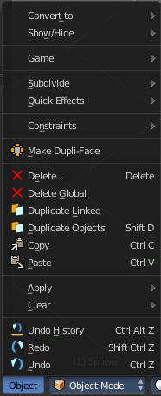
The object menu in Object mode provides you with tools to work at Object level.

It contains things like undo redo, copy and paste, delete and other general tools. But also some object specific tools, like the Convert to menu.

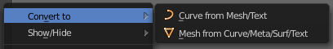
Convert to
Convert to is a menu to convert curves object types to mesh objects, and mesh object types to curves.

Curve from Mesh/Text
Converts a selected Mesh or Text Object to a Curve Object.

Mesh from Curve/Meta/Surf/Text
Converts a selected Curve, Metaball, Surface or Text Object to a Mesh Object.

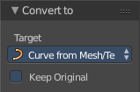
Last Operator Convert to
Target is a drop-down box where you can again choose between the two convert methods.
Keep Original
With this option ticked the original object gets kept. And a new object gets created.

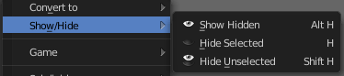
Show/Hide
Show/Hide is a menu. Here you can show or hide objects in the viewport. See chapter All Modes, all Object types - Show / Hide

Game
Game is a menu that is related to the Blender Game Engine. Bforartists does not give any support for the Game Engine. Please head over to the Blender Manual when you want to learn more about this menu.

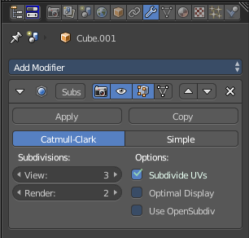
Subdivide
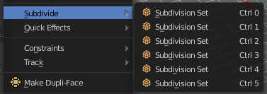
Subdivide is a menu where you can quickly add and change a subdivision surface modifier with a predefined resolution in a quick way. Especially when you use the hotkey for it. The subdivision surface modifier panel can then as usual be found in the Properties editor in the Modifier tab.

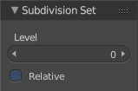
Last Operator Subdivision Set

Level
Here you can set the level of subdivisions

Relative
Applies the sub surf level as an offset to the already existing sub surf level.

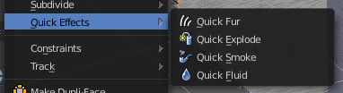
Quick Effects
Quick effects is a menu with some predefined basic Particle effects. You need to have a mesh object selected.

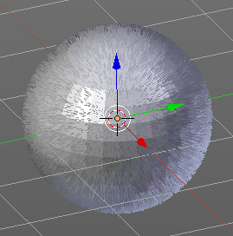
Quick Fur
Adds a particle system with Fur settings.

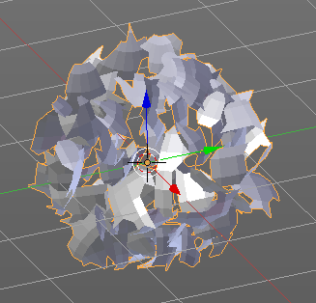
Quick Explode
Adds a particle system that lets the selected object explode into pieces.
Hit play to play the animation.

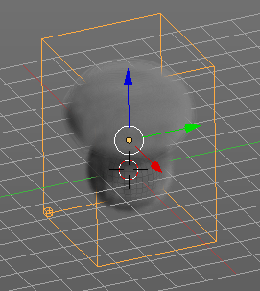
Quick Smoke
Adds a particle system with a simple smoke.
Hit play to play the animation.

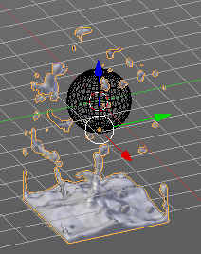
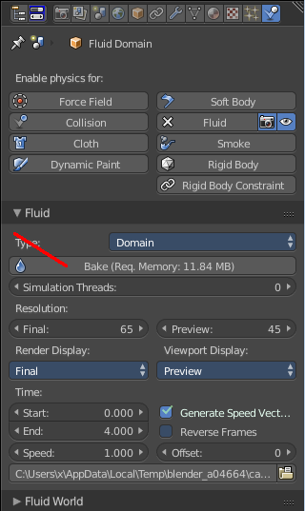
Quick Fluid
Adds a particle system with Fluid settings.
This feature does not completely work out of the box. You need to bake the animation first. This can be done in the Properties Editor, Particles Tab, Fluid Panel.

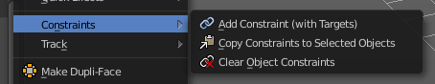
Constraints
Constraints is a menu around Constraints functionality. Constraints provides you with various limitation methods connected to a target object. For example, you can limit the X position of an object to the X position of the target object. And when you move the target object, then the object will change its X position too.

Add Constraints ( With Targets)
Add Constraints ( With Targets) calls a menu where you can choose the constraints type. It's the same content than in the Constraints tab in the Properties editor.
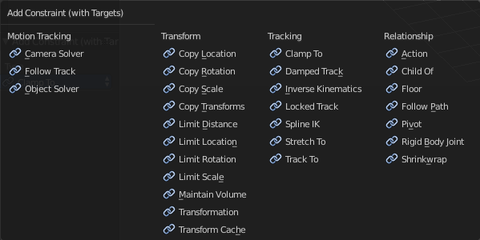
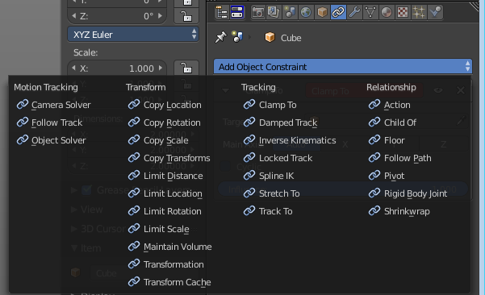

We will not explain every single constraint type here. Please have a look at the constraint types in the manual part for the Properties editor.
Usage:
Select the target object. Hold down Shift key. Now select the object where you want to add the constraints to. Both should be selected. Then choose the constraints type in the menu that you want to add.
As a result a constraints panel gets created in the Constraints tab in the Properties editor. Here you can tweak the settings then further if required. In our example we wanted to limit the X axis. So we added a Copy Location constraint, and unticked Y and Z axis.
In the 3D view a black dotted line indicates the relationship.
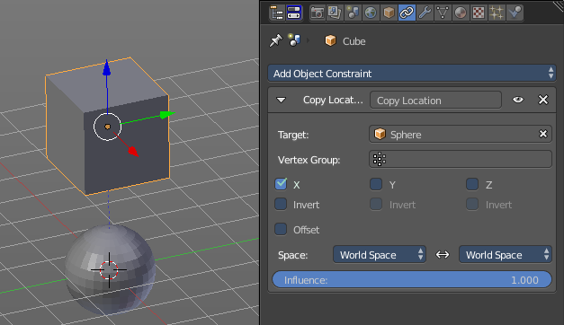

Last Operator Add Constraints (with Target)

Type
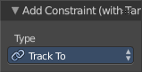
Type is a drop-down box where you can choose the constraints type again.

Copy Constraints to Selected Objects
Copy Constraints to Selected Objects copies a constraint from one object to another.
Usage:
Select the object where you want to copy the constraint to. Hold down Shift and select the object with the constraint. Both should be selected. Then click at Copy Constraints to Selected Objects. This copies the constraint to the object.

Clear Object Constraints
Removes all constraints from the object.

Clear Track
This menu item is just relevant when you have a Track constraint applied. It removes the track constraint.

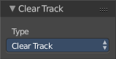
Last Operator Clear track

Type
Type is a drop-down box where you can choose between Clear Track and Clear Track Keep Transformation.

Clear Track - Keep Transformation
This menu item is just relevant when you have a Track constraint applied. Removes the track constraint. But keeps the current position.

Last Operator Clear track

Type
Type is a drop-down box where you can choose between Clear Track and Clear Track Keep Transformation.

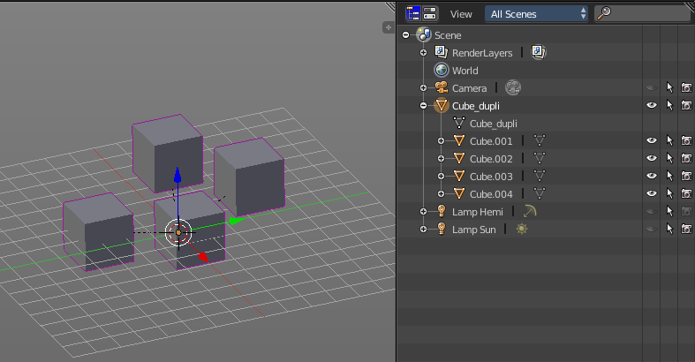
Make Dupli Face
Make Dupli Face is a relict from the past, when there was no instancing or parenting feature available in Blender. When you turn an object into a Dupli Face object, then this object becomes an instancing container for this object. All objects in this container just exists once in ram when you duplicate it. No matter how often you duplicate it. This allows to plant whole forests without to run into a memory problem. Since the tree object just loads once into ram. And gets just drawn at different screen positions then.

Delete
Delete deletes the selected object(s)

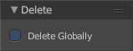
Last Operator Delete

Delete Globally
When ticked then the delete operation deletes global, in all scenes.

Delete Global
It can be that you have more than one scene open. Delete deletes the selected object(s) in all scenes.

Last Operator Delete

Delete Globally
When ticked then the delete operation deletes global, in all scenes.

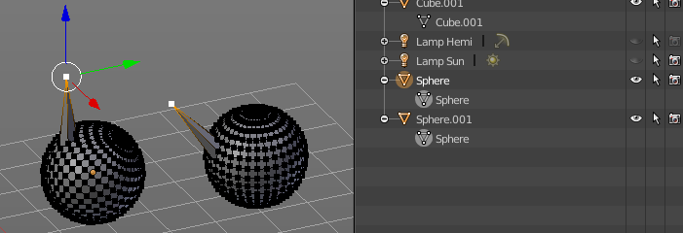
Duplicate Linked
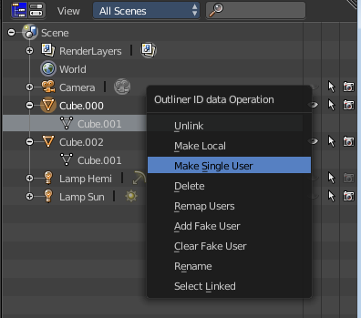
Duplicates selected objects. The instance has its own transforms. But the duplicate shares some data with the first instance. This means when you for example edit the mesh of one of the instances, then the other instance gets modified too. As you can see this in the screen shot. Here you can also see that the mesh name is the same.
If you want to make changes to an object in the new linked duplicate independently of the original object, then you will have to manually make the object a “single-user” . This can be done for example in the Outliner, in the right click menu of the object.
You are automatically in grab mode, and so you can easily move the object out of position. which is sometimes wanted, since you can position the duplicate then. But sometimes this is unwanted. A right click after releasing the mouse lets the object snap back into its creation position.
Duplicate linked instances the object data.
Explanation: Each Bforartists object type (mesh, lamp, curve, camera etc.) is composed from two parts: an Object and Object Data (sometimes abbreviated to ObData):
Object - Holds information about the position, rotation and size of a particular element.
Object Data - Holds everything else. For example. Meshes stores geometry, material lists, vertex groups, etc. . Cameras stores focal length, depth of field, sensor size, etc. .
Each object has a link to its associated object-data, and a single object-data may be shared by many objects.

Hint
If you want to make changes to an object in the new linked duplicate independently of the original object, you will have to manually make the object a “single-user” copy by LMB the number in the Object Data panel of the Properties Window.

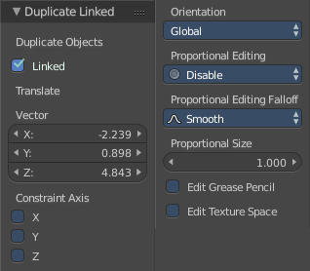
Last Operator Duplicate Linked

Duplicate Objects

Linked
With this option ticked the duplication happens with linked data.

Translate
The Position of the duplicated object

Constraint Axis
Here you can limit the position relative to the source object.

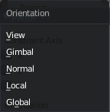
Orientation
Orientation is a drop-down box where you can choose the type of orientation for the mirroring action.

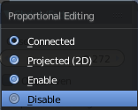
Proportional Editing
Proportional Editing is a drop-down box where you can choose to use proportional editing. When you choose one of the active methods then the neighbour geometry gets influenced by Shrink/Fatten too in a proportional way.

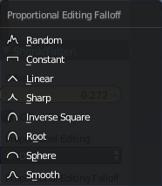
Proportional Editing Falloff
Proportional Editing Falloff is a drop-down box where you can choose a method for the falloff for the proportional editing.

Proportional Size
Proportional size is a edit box where you can adjust the strength of the Proportional falloff.

Edit Grease Pencil
Edit Grease Pencil edits the selected Grease Pencil strokes.

Edit Texture Space
With Confirm on Release checked the action gets performed when you release the mouse button.

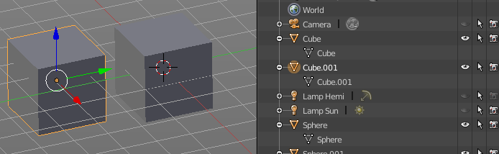
Duplicate Objects
Duplicates selected objects. The copy is completely independent. All containing data gets duplicated too. And you can edit the object instances completely independent. then.
You are automatically in grab mode, and so you can easily move the object out of position. Which is sometimes wanted, since you can position the duplicate then. But sometimes this is unwanted. A right click after releasing the mouse lets the object snap back into its creation position.
When you drag the duplicate around you will see the position values in the header.

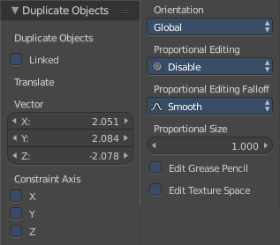
Last Operator Duplicate

Duplicate Objects

Linked
With this option ticked the duplication happens with linked data.

Translate
The Position of the duplicated object.

Constraint Axis
Here you can limit the position relative to the source object.

Orientation
Orientation is a drop-down box where you can choose the type of orientation for the mirroring action.

Proportional Editing
Proportional Editing is a drop-down box where you can choose to use proportional editing. When you choose one of the active methods then the neighbour geometry gets influenced by Shrink/Fatten too in a proportional way.

Proportional Editing Falloff
Proportional Editing Falloff is a drop-down box where you can choose a method for the falloff for the proportional editing.

Proportional Size
Proportional size is a edit box where you can adjust the strength of the Proportional falloff.

Edit Grease Pencil
Edit Grease Pencil edits the selected Grease Pencil strokes.

Edit Texture Space
With Confirm on Release checked the action gets performed when you release the mouse button.

Copy
Copies the selected object(s)

Paste
Pastes copied object(s).

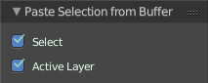
Last Operator Paste Selection from Buffer

Select
Select pasted object(s).

Active Layer
Paste the object into the active layer.

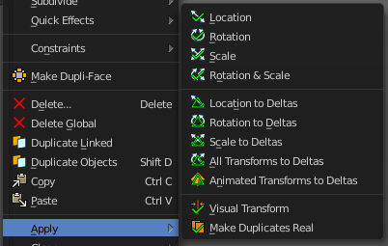
Apply
Apply is a menu where you can apply transforms in various combinations. For example, when you create a cube, then move it to let's say 3, then apply the location, then the origin gets set to 0. The position is "applied". Of special Interest is apply scale, since it resets the scale factor to 1.
Apply just works with single user objects. And it does not apply to pose position, animation curves or constraints. These tools should be used before rigging and animation.

Location, Rotation, Scale and Rotation&Scale
This applies the location, rotation and scale of the object.

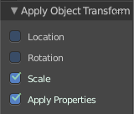
Last Operator Apply Object Transform.

Location
Applies the position, and resets origin to 0

Rotation
Applies the rotation.

Scale
Applies the Scale.

Apply Properties
Properties such as Curve Vertex Radius. Font Size and bone envelope gets applied.

Location, Rotation, Scale and All Transforms to Deltas
Transforms are absolute to the world coordinates. Delta Transforms are relative to the current transformation.
The delta transform values can be found in the Object properties, in the Delta Transform Panel.
Example use case:
Keyframe a object rotation from 0 to 90 degrees. Rotate the object by 45 degrees. When you play the animation it will still rotate from 0 to 90 degrees.
Now keyframe a delta rotation from 0 to 90 degrees and rotate the object by 45 degrees. When you playback the animation it will rotate from 45 to 135 degrees now. (a 90 degree difference from the current state)

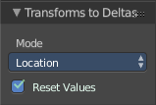
Last Operator Transforms to Deltas

Mode
Mode is a drop-down box where you can choose the transform mode again.

Reset Values
Clears the transform values after transferring to Deltas.

Animated Transform to Deltas
Converts the “normal” transformation animations to Delta transforms. This tool requires to have key frames at the object.

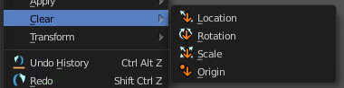
Clear
Clear Transform is a menu where you can clear the transform for location, rotation, scale and Origin. Clear means in this conjunction that the values gets reset. When you have for example a cube at X 5, and clear the location, then the cube gets positioned at position X 0.

Location
Resets the location of the selected object(s).

Last Operator Clear Location

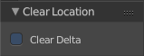
Clear Delta
With Clear Delta ticked it clears the delta transform instead of the transform.

Rotation
Resets the rotation of the selected object(s).

Last Operator Clear Rotation

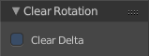
Clear Delta
With Clear Delta ticked it clears the delta transform instead of the transform.

Scale
Resets the scaling of the selected object(s).

Last Operator Clear Scale

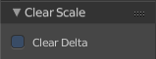
Clear Delta
With Clear Delta ticked it clears the delta transform instead of the transform.

Origin
Clear Origin requires to have a parent child relationship selected. It sets the child object to the position of the parent object.

